## BNWAS

The BNWAS (Bridge Navigational Watch Alarm System) is a similar personal safety system, designed for use on the bridge.

### Introduction

It is possible that you use the BNWAS as a standalone version, but it can also be used in conjunction with the UniMACS bridge. It can even be used with other bridge systems as long as these systems give the standard EVE-messages.

In this manual, we will address both ways in the same explanation since their differences are mainly HMI-related and do not affect functionality.

When we discuss the interface of the BNWAS system, it can be the interface on the standalone BNWAS or on the integrated BNWAS. It can be the interface on the bridge-panel, but also the interface on the panel in the captain’s cabin. What follows is an integral explanation of the BNWAS functionality.

### The HMI overview

The HMI consists of a main screen that holds all functionality for the BNWAS and a setup-screen that can be used to enter the necessary settings. In the following figures, we will explain the functionality and functions on the HMI.

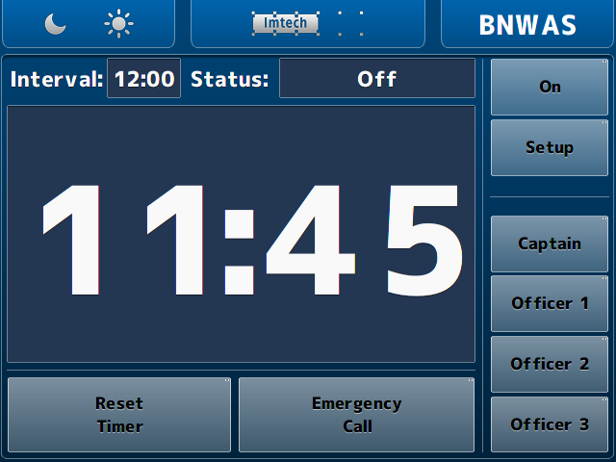

Figure 3‑2: Main BNWAS HMI

### The HMI explained

The functions of the HMI are described in the following figures. These are mostly self-explanatory. Where not explicitly clear, an additional explanation is given.

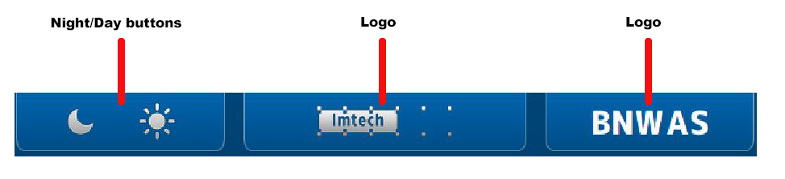

Figure 3‑3: HMI top bar

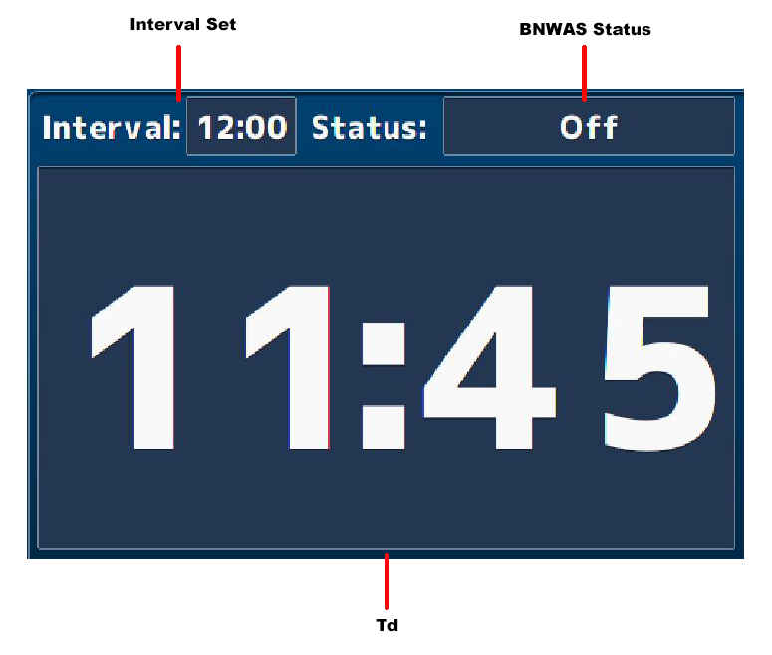

Figure 3‑4: HMI main screen

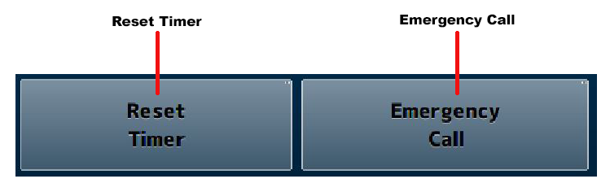

Figure 3‑5: HMI bottom bar

*The reset timer and emergency call buttons are only available when the panel is placed on the bridge. Any other location will show these buttons, but they will not be operational.*

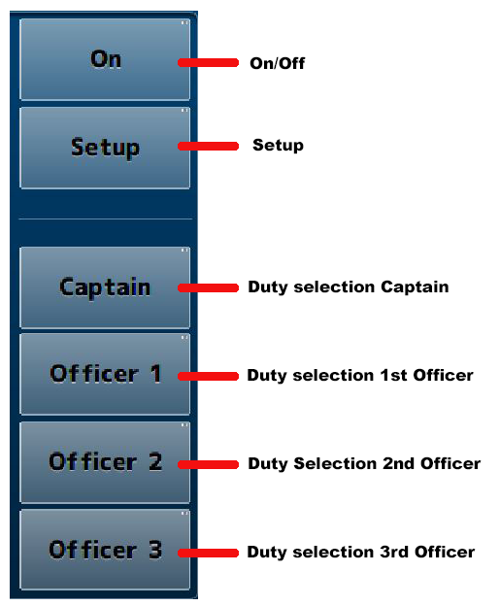

Figure 3‑6: HMI Panel

* When you operate the* On/Off *or* Setup *button a keypad will appear where you have to type a passcode. (See* Figure 3‑8*).*

### The setup page

By clicking on the setup button a new screen will appear. This is the setup screen. It looks quite the same as the main window as it has only a few settings in the main panel (see Figure 3‑9).

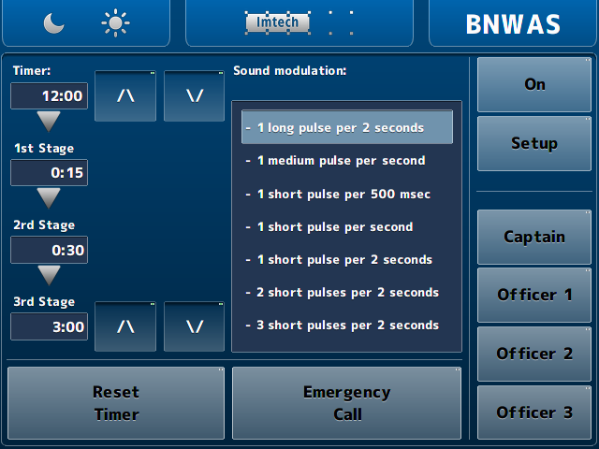

Figure 3‑7: Setup screen

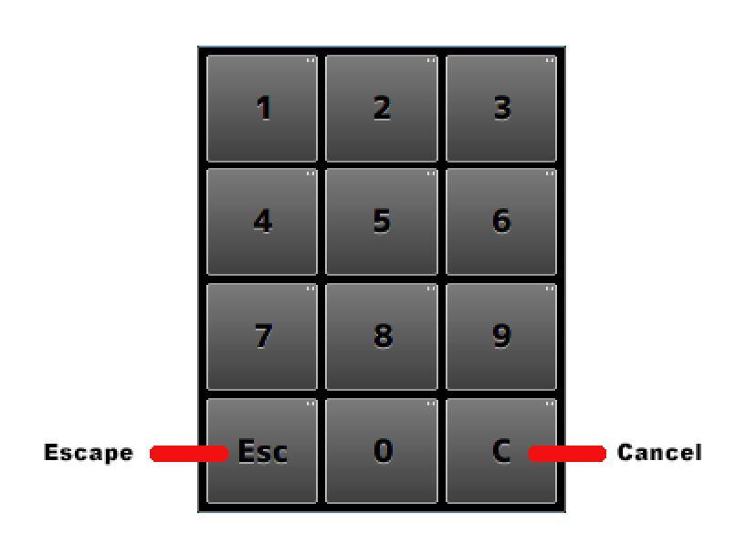

Figure 3‑8: Keypad

The functions, with their respective explanation, are shown in the following figure.

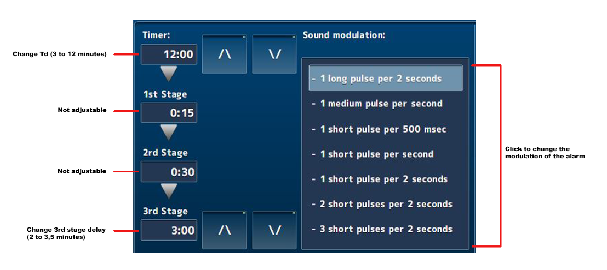

Figure 3‑9: Setup main screen

*With the arrow buttons in the setup page, you can increase or decrease the Td and/or 3rd stage delay time.*

Once a working NavVision server is connected to the same system, the HMI of NavVision will be overwritten on the DAP’s. It is just the HMI. The BNWAS will still be the one that handles all the BNWAS features.

It will look as in the following figure:

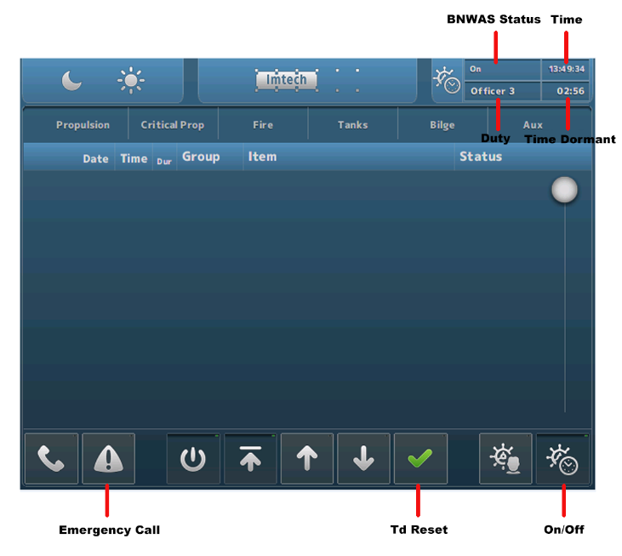

Figure 3‑10: NavVision HMI on DAP

On the NavVision server, you will have an equal kind of display as shown in the following figure.

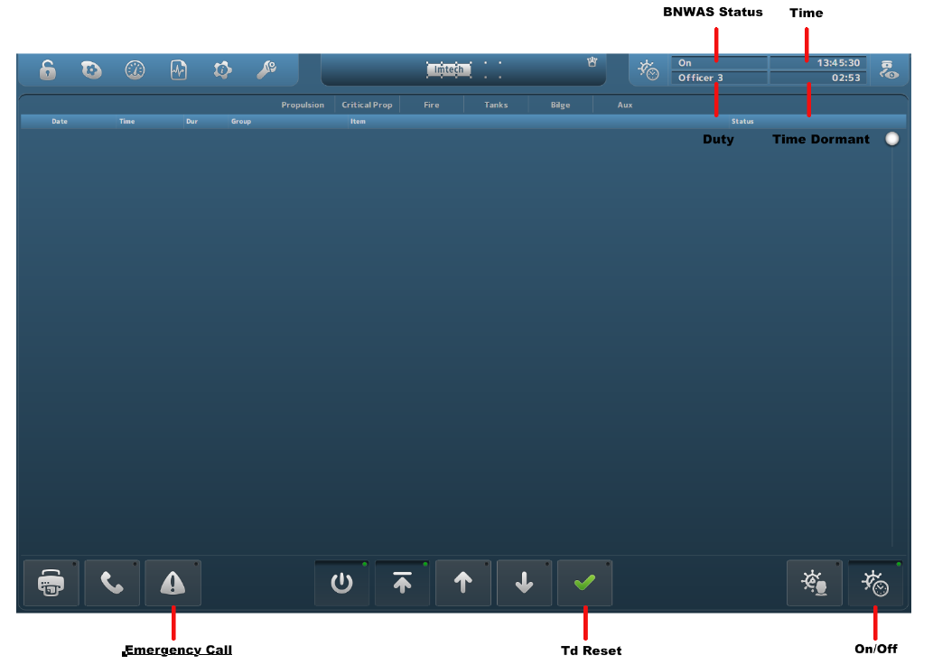

Figure 3‑11: NavVision Native screen